PPG Meeting | 14.08/2023  1 pm  Face-to-face
Meeting called by: | Noorin Akhtar | Minute Taker: | Abdul Qadir
Attendees: | Noorin Akhtar  Abdul Qadir  Chris Vaughn  Tahir Parvaz  Michael Bailey  Maverney Kettle  Wendy Richards

Apologies

Nil

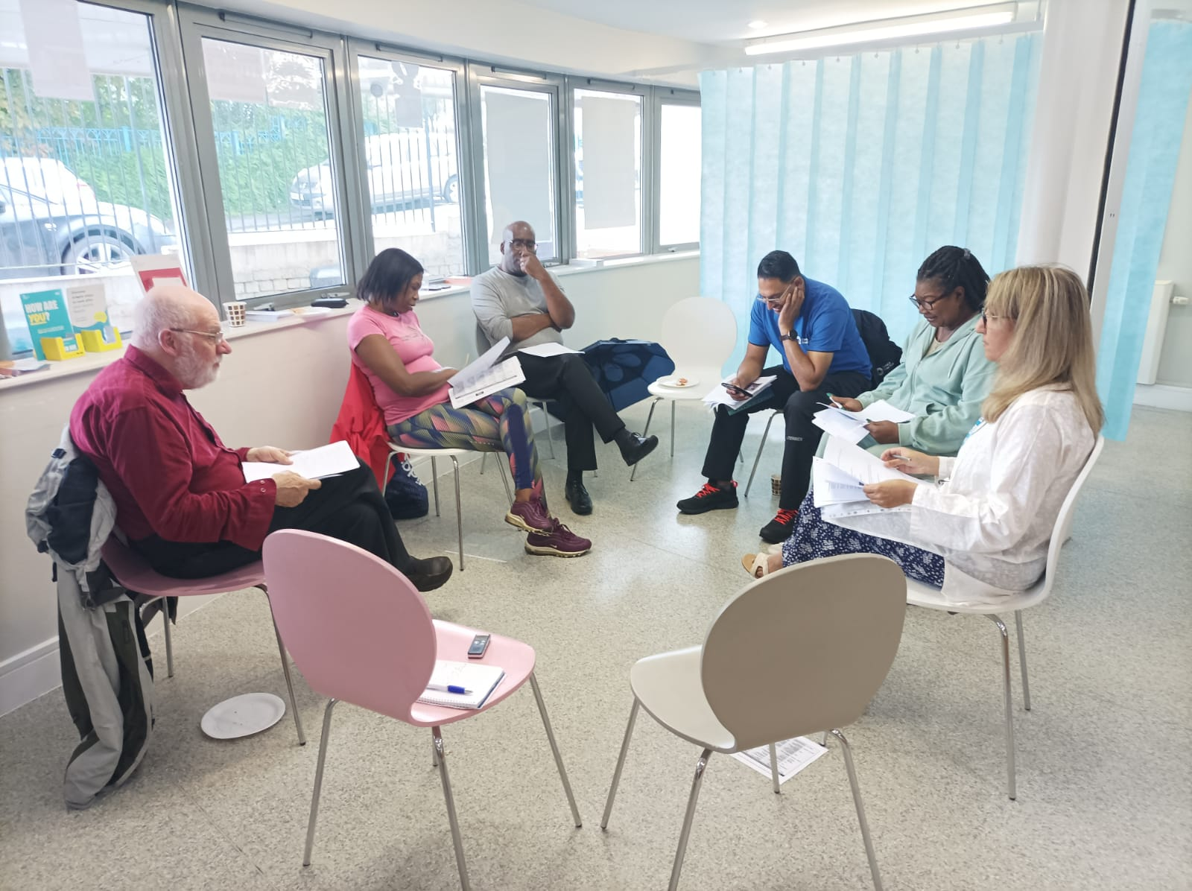

Minutes
Agenda item: | 1.0 Welcome and House keeping | Presenter: | Chris

Discussion:
1.1 Chris welcomed and thanked everyone for coming.

Agenda item: | 2.0 Meeting minutes approval | Presenter: | PPG Chair & everyone

Discussion:
2.1 Meeting minutes and actions were approved as accurate. There were some misspelt names which will be corrected.

Agenda item: | 3.0 Practice update | Presenter: | Noorin Akhtar
Discussion:
3.1 No new updates or complaints since last week.

Agenda item: | 4.0 GPCPS | Presenter: | Noorin Akhtar
Discussion:
4.1 Noorin informed everyone that there is a new government initiative called GPCPS which is a procedure and process to refer minor ailments to the pharmacy. The initiatives’ purpose is to save money on prescriptions and reduce the pressure on doctor surgeries. The government is monitoring surgeries for compliance with the new service.

4.2 Noorin explained that the reception staff have a minor ailment health navigation guide (provided to all attendees) is used to book in for triage. Note: children will remain in the surgery and the rest will be referred to the local pharmacy if they meet the criteria.

4.3 A Clinician will do the triage and decide where to refer. This may be to the local Pharmacy, Nurse, Social Prescriber, or GP for complex cases.

4.4 Noorin Emphasized that any service provided through the GPCPS system is free of charge. Further explained that the pharmacy triages patients again and decides to either accept or return the referral. Note: any non-NHS services provided by the pharmacy will need to be paid for e.g., ear syringing.

4.5 Some patients have been informed about GPCPS through texts and the service is being promoted by the government too with advertisements on TV, Buses etc.

4.6 The patient is followed up after 2 or 3 days to see if their problem has been resolved. If the problem still remains then the patient is booked in with a clinician.

4.7 A decision was made to make an audit list of the percentage of returned referrals from the pharmacy after Wendy asked about the returned referral percentage.

4.8 Wendy expressed concern about missing any problems? Noorin mentioned a case of a patient who had numerous problems and how the GPA resolved all the problems by doing relevant referrals and followed-up the patient up to make sure everything was resolved. The case study will be looked at in detail in the next meeting.

4.9 Wendy expressed a concern about the danger of missing a diagnosis by breaking up multiple problems. Therefore, a system will be made to avoid missing any diagnosis in such cases.

4.10 Noorin reported that doctors will make more video calls to better the assessment done over the phone.

4.11 Action will be taken to inform the patients about the new GPCPS system.

Agenda item: | 5.0 telephone message | Presenter: | Noorin Akhtar
Discussion:
5.1 Tahir liked how patient waiting times will be reduced by message 1’s button options, information on when to call to book an appointment or request repeat medications.

5.2 The emergency contact number information provided in message 2 was approved.

5.3 Chris suggested making mention of the walking group. Maverney suggested adding a day and time to call for test results. Wendy suggested allowing patients to press the optional buttons without hearing the full message.

Agenda item: | 6.0 Action plan for customer service | Presenter: | Noorin Akhtar
Discussion:
6.1 Approved the staff giving their name to enable in patient to chase up their query.

6.2 Suggested giving patients a choice of being referred to the pharmacy and explaining the journey of the referral. Be friendly, open, and honest. Have a structural professional relationship to follow-up and see if the issue(s) has been resolved and ask if they have any other concerns.

6.3 Decision reached to make customer service action plan an item on the standing agenda.

Agenda item: | 7.0 Patient surveys | Presenter: | Noorin Akhtar / PPG Chair
Discussion:
7.1 Action plan will be presented at the next meeting for two areas where we scored lower than the ICS. Noorin requested everyone to review the statistical data sheet at home and suggest improvements at the next meeting.

7.2 It was noted that out of the 916 surveys sent out only 140 surveys were sent back. Therefore, a decision was made to inform patients about the survey and to help fill out the form if needed.

Agenda item: | 8.0 Investors in people/students | Presenter: | Noorin Akhtar
Discussion:
8.1 The surgery was at a standard level in Investor in people and has now become level Silver for investors in people for staff and apprentices.
8.2 The upcoming review will be next year.

Agenda item: | 9.0 AOB | Presenter: | Noorin Akhtar
Discussion:
9.1 Next PPG meeting will be held on 4th September 2023.

9.2 Decision reached to encourage patient involvement in the PPG meeting by sending out texts. Chris suggested along to write something along the lines of “can you help us please.”

Action items |  | Person responsible |  | Deadline
- Audit list of returned pharmacy referrals |  | Noorin |  | ?
- Case study of triaging a patient with numerous problems |  | Noorin |  | 4/09/2023
- Inform patient of GPCPS | Noorin |  | ?
- Add Customer service action plan to standing agenda |  | Noorin |  | ?
- Inform patients of the patient survey  - Encourage patient involvement in PPG meetings |  | Noorin  Noorin |  | ?  4/09/2023

Other Information

Special notes:
Please make sure you let Abdul know if you cannot attend the next meeting which will be held at 1 pm on 4/08/2023 face-to-face.

Standing agendas are the welcome message in the telephone and Customer service action plan.

If you would like anything added to the agenda, please let Chris know before the next meeting.

Any further questions or problems regarding the meetings, please let Chris know as soon as possible. Please always bring feedback to the meetings. This ensures that both staff and the patients are kept safe.

