PPG Meeting | 04.09/2023  1 pm  Face-to-face
Meeting called by: | Noorin Akhtar | Minute Taker: | Abdul Qadir
Attendees: | Noorin Akhtar  Abdul Qadir  Christopher Vaughan  Tahir Parvaz  Michael Bailey  Maverney Kettle  Wendy Richards  Love Appiah-Badu  John Condon  J Brown  W Richards
Apologies: | Zahid Mahmood  Mohan Ramachandran

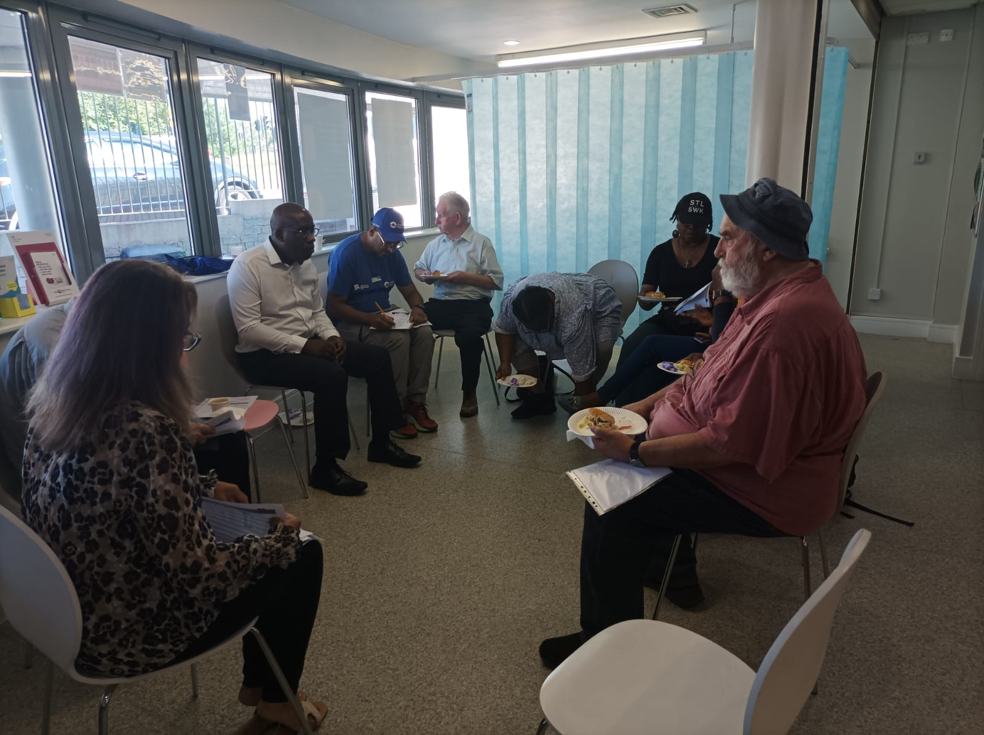

Minutes
Agenda item: | 1.0 Welcome and House keeping | Presenter: | Chris

Discussion:
  - Chris welcomed and thanked everyone for coming.

  - Chris enquired Noorin of the recent news from government about practitioners which may be seen in a GP. Noorin confirmed there will trainee paramedics will be joining soon for a sometime and after they leave there will be a fixed paramedic attached to the surgery.

A Physiotherapist is not attached to the surgery, but the surgery has joined a polit app called ROH (Royal Orthopedic Hospital) which provides a Physiotherapist service. The service is starting in November and the GP will be the “first contact practitioner” who can refer patients to this app if needed.

There are two care coordinators, a social prescriber, 2 clinical pharmacists, and 4 nurses.

There is no Physician Associate but there is an Advanced nurse practitioner instead. There are no Nursing Associates, but the surgery will have a full nurse joining in May next year that can do everything.

There is no Health and Wellbeing Coach, but the social prescriber refers to them. No Mental Health practitioner as they are difficult to find; patients referred to mental health services by social prescriber. No Dieticians attached; patients referred to Birmingham community healthcare. No Podiatrist or an Occupational Therapist with surgery.

Agenda item: | 2.0 Meeting Minutes Approval | Presenter: | Chris & Everyone

Discussion:
2.0 Everyone approved the meeting minutes.

2.1 The action log was discussed; Noorin updated everyone about the status of tasks and what work has been done for each task.

Noorin reported that Patient Voice will be added to the Flourish meetings and two of our doctors have attended and spoken about the work they have done in their specialized areas. Noorin aims to attend the upcoming Flourish meetings.

It was decided to change the status of the completed action of encouraging patient involvement in PPG meeting to “in Progress at 25%” because of the low patient turn out at the PPG meeting.

It was decided to have Menopause workshop for both men and women separately and together at times to educate all patients.

Agenda item: | 3.0 Practice Update | Presenter: | Noorin

Discussion:
3.1 Noorin informed everyone the surgery is holding a “Stake Holders meeting patient voice meeting “on 25th of September. This meeting will be like an Annual general meeting where everybody is invited.

The discussion will entail the surgeries past, present and plan for future. Mike will be talking about Health and Social Care. Taz agreed to talk about the walking group. Chris agreed to talk about the PPG. An investor in people’s member called Sharon Row, will be facilitating the meeting.

3.2 The conference room will be knocked down soon to make room for two new consultations rooms.

Agenda item: | 4.0 Meeting Schedule | Presenter: | Noorin

Discussion:
4.1 The meeting schedule was approved.

Agenda item: | 5.0 Patient Survey Action Plan | Presenter: | Noorin

Discussion:
5.1 Noorin requested ideas to improve patient time with health care professionals to resolve their problems as the score was 53% and it should be 84%. States only 12% of patients responded from 1000 surveys that were sent out to random patients.

Noorin stated the time restraints for doctors is 10 minutes and nurses time vary depending on the type of clinic.

5.2 Chris suggested telling patients to write down what their problem is and what they want to from the doctor to use the doctor’s time efficiently.

5.3 Wendy suggested telling patients the time limit of the doctor and advising prioritizing their problems.

5.4 Wendy suggested the practice to be mindful of keeping to appointment times to avoid patient disappointment.

5.5 Pauline suggested asking paitient which doctor they would like to be booked with.

Action to update the surgery website for doctors’ information and their specializations.

5.6 Noorin stated surgery provided same day appointments and books in for the next day in case of overflow. Any non-urgent issues, sick notes, and results are booked for the next day. On Friday all missed calls during the week are returned to clear up any outstanding issues.

5.7 The surgery will improve patient response to the GP Patient Survey by sending text messages in June/July to give awareness about the GP Patient surveys which NHS England get posts in April/May.

5.8 It was decided to get a copy of the GP Patient Survey to learn if patient details are included in the form because people like to stay anonymous when providing feedback.

Action items |  | Person responsible |  | Deadline
- Change status of the task to encouraging patient involvement in PPG meeting |  | Abdul |  | 4.09.2023
- Menopause workshop for Men and Women; both separate and combined workshops |  | Mike |  | ?
- Add patient survey suggestions to Patient Survey Action Plan | Noorin |  | ?
- Obtain copy of the GP Patient Survey |  | Noorin |  | 6.11.2023

Other Information

Special notes:
Please make sure you let Abdul know if you cannot attend the next meeting which will be held at 1 pm on 6/11/2023 face-to-face.

Standing agendas are the welcome message in the telephone and Customer service action plan.

If you would like anything added to the agenda, please let Chris know before the next meeting.

Any further questions or problems regarding the meetings, please let Chris know as soon as possible. Please always bring feedback to the meetings. This ensures that both staff and the patients are kept safe.

