PPG Meeting | 7.08/2023  1 pm  Face-to-face
Meeting called by: | Noorin Akhtar | Minute Taker: | Abdul Qadir
Attendees: | Noorin Akhtar  Abdul Qadir  Chris Vaughn  Robert Seargent  Tahir  Michael Bailey  Julia  Narvina  Jane Do

Apologies

Nil
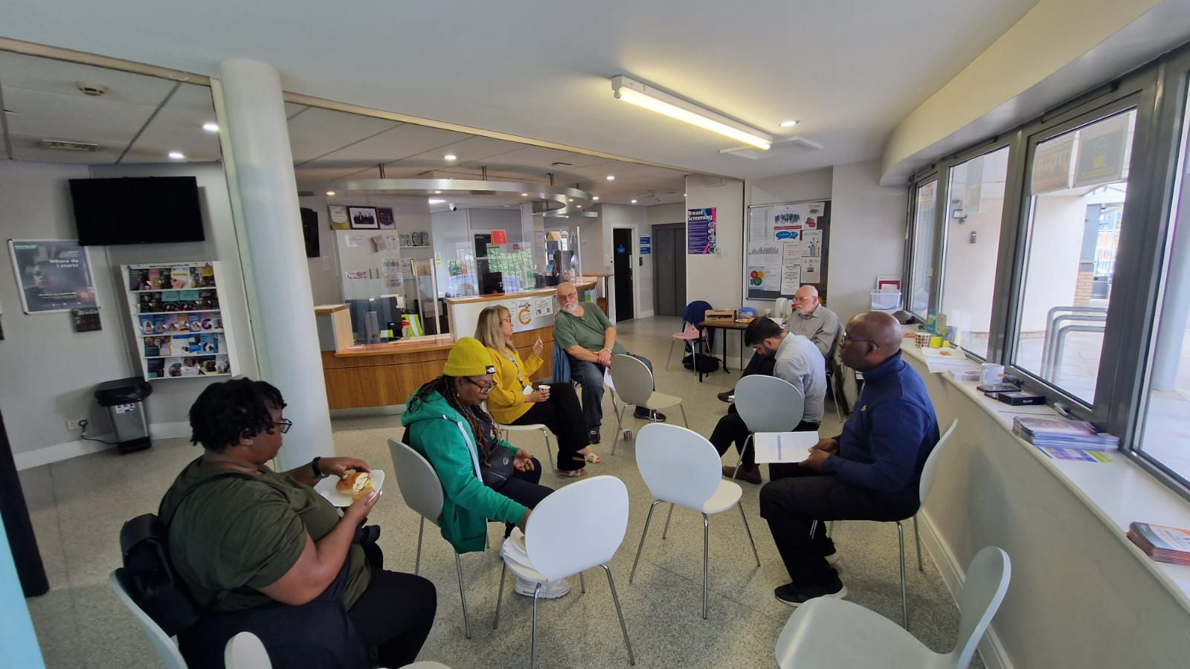

Minutes
Agenda item: | 1.0 New Staff | Presenter: | Noorin Akhtar

Discussion:
  - Noorin said we have new HCA trainees (Health Care Assistants), who can deal with chronic diseases, height, weight, blood pressure etc. There is a system that provides recommended checks for patients when they come into the surgery and the HCA will perform the checks and if there is any problem then they are booked with the onsite doctor or nurse.

  - There is one office manager, an Advanced nurse practitioner, 3 nurses, and another nurse set to join in March once she has qualified later this year.

  - Chris asked if the nurses here are specialized in any areas?

  - Noorin answered that the nurses specialize in different areas; so, nurse Sarah specializes in Immunisations, Asthma, COPD in adults and children. Nurse Maryam can do everything.

  - Maryam and the other nurse are trained in chronic diseases. Maryam has recently qualified with Warwickshire University and has achieved a diabetes certificate which means she can initiate insulin to diabetic patients.

  - Noorin mentioned there are 4 pharmacists; Nick, who is our PCN, he does medication management and stratifications. Murzena does minor elements. Adnan does structured medication reviews, Nasar can do everything including emergency medication, fridge, stock checks etc., Harpreet is the pharmacist technician.

  - Noorin stated there are 8 doctors working for the surgery detailing they joined during the surgery during COVID after leaving medical school.

Dr Mavi leads in Diabetes, working two days with at surgery and is the Diabetes lead for West Birmingham.

Dr Malik works 3 days for the surgery, leading in respiratory and pediatrics, has now become the West Birmingham hub lead.

Dr Tahir Saeed leads the elderly, falls, fractures etc., was the falls lead in West Birmingham.

Dr Hasnain Saeed works at Queen Elizabeth Hospital and does a day of work for us on a Wednesday.

Dr Zeb also works in Queen Elizabeht hospital in the A&E department and does 4 days of work in the surgery.

Dr Adeel Ahmed is a newly qualified doctor who joined the practice at the beginning of the year. Dr Ahmed started at the surgery as a student doctor and trained under Dr Aslam in 2021, then qualifying in August 2022 last year and joined the surgery in September 22, currently working 3 days for the surgery. Nurse Azam is an ANP who does 2 days for the surgery.

  - Chris enquired about the doctor who spoke met the walking group and spoke on care navigation.
Noorin answered that it was Dr Kian (Trainee Registrar from the hospital), and he did some work which will be presented in September.

  - Noorin said all doctors are doing consultations via telephones and face-to-face if required.

Agenda item: | 2.0 POD | Presenter: | Noorin Akhtar

Discussion:

2.1 Noorin said the Prescription Ordering Department has been decommissioned, the surgery is now taking calls instead, and we try to encourage patients to order using the My GP if know how to use a smartphone to make their lives easier.

Initially the My GP app started off as word of mouth and slowly increased its usage. The surgery plans to promote the app next via text, there is just some coding elements to sort out first before sending the promotional texts to patients.

Agenda item: | 3.0 Telephone Access | Presenter: | Noorin Akhtar
Discussion:

3.1 Chris asked about telephone access, adding he himself has experienced long waiting times on the telephones.

3.2 Noorin replied that we will see a change now, being a part of Urban Health PCN, which is group of surgeries that have come together to deliver health care services. This means you get to travel to these other surgeries for facilities that are present in Broadway Health Centre. For example, if Spirometry referral is needed and one of the practices has this service, we then will refer our patients there.

The surgery is planning to change the welcome message you hear when someone calls the surgery. The new message will be run past everyone in the next PPG meeting to allow for your contributions.

Another change is that there will be a cloud-based system to call you back automatically if the person cannot get through to the surgery. This system is operated by button the person needs to press and when the lines are free, the surgery will back straight away.

3.3 The surgery will provide treatment to patients who could not get through to book an appointment on the day. They will either be booked for the next day with the doctor, booked with a pharmacist, defer to social prescriber, deferred to the community pharmacist.

Any non-urgent problems will be booked for the next day with the GP, but in an emergency, you will be deferred to the A&E once the staff has run the problem past the doctor or the nurse.

The care navigation service given will be monitored.

3.4 Robert said the window of time to book an appointment is small.

Noorin said those patients who get through during that window of time will get an appointment on the day and if anyone who gets stuck in the que will be car navigated and Noorin ran through the care navigation system mentioned earlier.

3.6 Narvina asked how are patients with language barriers accommodated?

Noorin replied we reception staff that has been around for about 2 years, who know most of the patients, and a lot of them can speak the same languages, in case they don’t speak the same language as the patient, a 20-minute appointment is booked with GP and a translator from the interpreting service, and it is a 3-way call. If the appointment is face-to-face, then a translator will come into the surgery.

Narvina further detailed her question and said that the African Caribbean people are less inclined to access the health care service due to language barriers and the lack of cultural understanding in the health care service system. So how can we overcome this?

Noorin replied we have a health and inequality project, core 20 plus 5, Dr Aslam will talk about these projects in September. These projects include Hypertension, Maternity, mental health, which are about what we are doing to for patients to access these services.

Noorin said a common issue is where patients don’t contact the surgery and may have underlying high blood pressure and so we are encouraging those patients to go to their local pharmacist or visit the surgery.

3.7 Noorin said that some of the projects we are working on include pregnancy, respiratory, parental medication that will all be in September PPG meeting, and you can give your input then.

3.8 Chris mentioned that this surgery wasn’t one of the 20 worst GPs to book an appointment in, in the recent news article.

3.9 Noorin said there was a point just before COIVD when the surgery had an 81% satisfaction rating. Now the rating has gone down slowly to 56% percent, partially due to less people filling the patient surveys being sent out.

The surgery has started to work the customer service and put together an action plan. Name badges and uniforms are being looked at too.

A voice over IP system has kicked in that assesses the receptionist over the phone to see if the tone was friendly and if the caller left satisfied. The surgery will gradually bring the data into the meetings.

3.10 Noorin has submitted her action plan to the ICB on 30th of June which was accepted. The plans will begin to be implemented and the PPG group will be able to give their input, meaning accessing to the back admin to listen in on the conversations the staff are having with patients, and give any pointers on what is patient friendly etc.

3.11 The surgery is fortunate to have Michael Bailey, the social prescriber as he can get through to some patients who otherwise no staff member can solve their complaint. Noorin referred to a patient who had some issues recently and said she will be receiving a call from the social prescriber the following day, and after that once a week or every fortnight.

Michael said he made a phone call to the patient initially followed by a home visit, spoke to her in their common tongue, Potois, and the patient opened. Mike realized communication on both sides was the problem. Furthermore, Michael found that she needs urgently medical assistants, and booked the patient in for an appointment the next day once Noorin authorized it.

3.12 Noorin said we also have a care coordinator from the PCN who does 1.5 days and calls all the Over 75-year-olds once a month to see if they need any help and arranges for call backs with the doctors or Michael for complex patients.

The doctor has very recently contacted all the palliative care patients by video call.

3.13 Julia said there are other people who want to take part in these PPG meetings but can’t’ due to work commitments, is there any way for them to have their input?

Mike answered that just before the meeting Noorin said we will be holding teams meetings in the evening too next time.

Agenda item: | 4.0 Primary Care Network | Presenter: | Noorin Akhtar
Discussion:

4.1 Noorin stated that we are part of the Urban Health primary care network, which consists of 3 practices: Newport, Halcyon and Broadway Health Centre. The population count is 32,000 in total and next year the funding that comes will be distributed to the surgeries based on targets and outcomes.

4.2 The PPG meeting in September will be a patient, community and stake holder meeting so anybody can walk into the discussion about the health and inequality project for managing patients, your suggestions, any feedback etc.

4.3 Chris asked is there a patient voice on the agenda in PCN meetings like there used to be before COVID?

Noorin says there isn’t a patient voice in the PCN meetings now. However, will be put in the suggestion and ask for feedback from clinical director. Now flourish has come, so had thought it started.

Chris said it is on the agenda, but they haven’t acted upon it. Chris thinks the GP and health professionals would benefit from having community input.

Noorin says she has a PCN meeting this Friday and will raise it up there and bring the feedback to you next week Monday.

Agenda item: | 5.0 Research Project | Presenter: | Noorin Akhtar
Discussion:

5.1 Noorin mentioned the surgery is working on a Menopause research project which is being piloted for one year. NICE is owner of the project, they want to help everybody who is going through menopause, give advice on managing the symptoms, what drugs to take etc. This help and advice is offered through the Stella app.

We have sent links to patients who are 40 years old and above. The app does an assessment via a questionnaire, to see if the person qualifies, granting one-year access to their services. The app is for women aged 40 – 60 y/o and if over 60, the app is free.

5.3 Broadway is an accredited Research practice. The surgery had research projects to choose from and chose menopause.

5.4 The surgery has pointed out a few things to the project holders, like the language barrier, whether the app costs the patients money when the pilot project ends after a year, and the pathway of returning the assessment to the surgery, including any drug recommendations.

5.5 Narvani commented that some people may not wish to take drugs and prefer natural remedies, and asked if the project has other ways to treat the symptoms rather than drugs.

Noorin replied that the project is drug based but she can put the natural remedy suggestion forward to them.

5.7 Mike says there is a menopause workshop for men elsewhere and he is in talks with the organizer of the workshop to provide the service to Broadway and will provide an update when possible.

Agenda item: | 6.0 Any other business | Presenter: | Noorin Akhtar
Discussion:

6.1 Tahir suggested a walk-in community room or a space in the surgery for activities such as sowing classes, seated exercises etc., said you could find providers and get health exchange tours who could deliver these programs. Suggested Gardening too.

Noorin agreed with the Tahir’s ideas and will investigate them.

6.2 Michael said that Warwick University did a lecture on some diabetes initiative programs and some of these programs will reach Broadway too.

6.3 Jane Do said that Ladywood leisure center gym has trained professionals who are there to help navigate people in gym that are referred from the doctor surgery. Says patients need encouragement to go the gym and need not be afraid of being alone in the gym.

Julia elaborated and said Ladywood leisure center has gym buddies who meet with patients and go over the exercises. The gym has coffee mornings every Tuesday, 10:30 – 11:30 am if anyone wants to take part. The gym is very keen to work with surgeries. Stated there will be an open day on 26th of September.

6.4 Noorin says we will have another catch up next week Monday 14th August 2023 at 1pm and after that the meetings will bi-monthly. The GP partner Dr Aslam will be attending the meeting in September. The meeting agenda will be sent out.

Action items |  | Person responsible |  | Deadline
- Welcome message in the telephone |  | Noorin |  | 14/08/2023
- Customer service action plan |  | Noorin |  | 14/08/2023
- Patient voice suggestion feedback from PCN meeting | Noorin |  | 14/08/2023
- Suggest natural remedy option to NICE in the Stella app |  | Noorin |  | ?
- Look at making a Community room or designated space  - Afternoon Teams meeting  - says there is a menopause workshop for men |  | Noorin  Noorin  Mike |  | ?  ?  ?

Other Information

Special notes:
Please make sure you let Abdul know if you cannot attend the next meeting which will be held at 1 pm on 14/07/2023 face-to-face.

Standing agendas are the welcome message in the telephone and Customer service action plan.

If you would like anything added to the agenda, please let Chris know before the next meeting.

Any further questions or problems regarding the meetings, please let Chris know as soon as possible. Please always bring feedback to the meetings. This ensures that both staff and the patients are kept safe.

